Pune Vidyarthi Griha’s College of Engineering and Technology & Management, Pune- 411009.
(Affiliated to Savitribai Phule Pune University)
A Project Report
On
“AarogyaNet - Healthcare Web Application”
Name Roll no
Raj Borade 3053
Vineet Warake 2005
Swarali Pawar 2090
Under The Guidance of
Prof. Mrs. S. V. Aslekar

INFORMATION TECHNOLOGY DEPARTMENT
Academic Year: 2025-2026
Contents

Sr. No. | Section Title | Page No.
1 | Introduction | 3
2 | Aim | 4
3 | Course Outcomes | 5
4 | Technologies Used | 6
4.1 | Front-end Technologies | 7
4.2 | Back-end Technologies | 8
5 | Description of Work Done | 9
6 | References | 13
7 | Conclusion | 14

1. Introduction

Healthcare is one of the most important sectors for human well-being, yet many people continue to face difficulties in accessing proper medical guidance, reliable health information, and nearby healthcare services. In many cases, individuals struggle to understand symptoms, identify the right medical professionals, or locate suitable hospitals and healthcare centers. With the increasing growth of Artificial Intelligence (AI) and digital technologies, there is a growing opportunity to develop intelligent systems that can simplify healthcare access and improve the overall user experience.
Aarogya Health Care Guidance is developed as an AI-powered healthcare assistance platform designed to address these challenges by providing users with accessible, efficient, and user-friendly healthcare support. The project focuses on combining healthcare guidance with modern technologies to create a digital ecosystem where users can receive medical-related assistance, explore healthcare resources, and access healthcare facilities more conveniently.
One of the major strengths of the Aarogya Health Care Guidance system is its ability to integrate multiple healthcare-related services into a single platform. Instead of relying on separate applications for healthcare information, doctor recommendations, or hospital location, users can access these features through one unified system. The platform includes AI-based healthcare support, doctor discovery, healthcare facility location, and health awareness resources.
This integrated approach improves accessibility and reduces the complexity users often face when searching for medical assistance. The multilingual and interactive design further enhances usability, making healthcare support more approachable for a wider population.
The project is developed using modern web technologies and follows a full-stack development approach to ensure responsive design, smooth functionality, and scalability. The frontend is designed to provide an interactive and user-friendly interface, while the backend handles healthcare-related processing and system logic efficiently.

2. Aim

In the present healthcare environment, many individuals face difficulties in accessing reliable medical guidance, identifying appropriate healthcare services, and understanding health-related information efficiently. Traditional healthcare systems often require users to depend on multiple sources such as websites, clinics, or separate applications for symptom guidance, doctor recommendations, and healthcare facility information. This fragmented approach can create confusion, delay medical support, and reduce healthcare accessibility, especially for users in rural or underserved areas. These challenges highlight the need for a more accessible and integrated healthcare guidance system that can simplify healthcare support for a broader population.
Another major issue in existing systems is the absence of a unified platform that combines healthcare guidance, doctor discovery, healthcare facility location, and awareness resources in one place. As a result, users may struggle to receive timely information or suitable healthcare recommendations based on their needs. In today’s digital era, where technology can significantly improve service accessibility, there is a strong requirement for a platform that can offer efficient healthcare guidance while improving awareness and convenience.
Therefore, the aim of the Aarogya Health Care Guidance project is to develop an AI-powered healthcare assistance platform that provides users with accessible, multilingual, and integrated healthcare support. The system is designed to guide users through healthcare-related concerns, improve awareness, assist in discovering healthcare resources, and simplify access to essential healthcare services through a single digital platform. By combining modern web technologies with intelligent healthcare features, the project aims to enhance healthcare accessibility, reduce information gaps, and promote a more efficient and user-friendly healthcare experience.

3. Course Outcomes

This project emphasizes the design and development of an intelligent healthcare guidance platform by integrating Artificial Intelligence, modern web technologies, and healthcare service accessibility into a unified system. Through the implementation of Aarogya Health Care Guidance, students gain exposure to real-world application development while focusing on user accessibility, healthcare awareness, and digital problem-solving. The project also strengthens the understanding of building socially relevant systems that address public needs through technology.
After the successful completion of this project, students will be able to:
- Understand the practical application of Artificial Intelligence and web technologies in developing healthcare-oriented digital solutions.
- Design and develop responsive, user-friendly applications that improve accessibility and user interaction.
- Implement integrated system functionalities such as healthcare guidance, resource discovery, and multilingual communication within a single platform.
- Apply full-stack development principles to create scalable and efficient real-world applications.
- Enhance technical, analytical, and problem-solving skills by addressing healthcare accessibility challenges through innovative system development.
- Develop the ability to create scalable, socially impactful, and technology-driven solutions for modern healthcare challenges.

4. Technologies Used

The Aarogya Health Care Guidance system is developed using a combination of modern web technologies and programming languages that work together to build an efficient, responsive, and user-friendly healthcare platform. These technologies are selected to ensure smooth frontend interaction, effective backend processing, and seamless integration of healthcare-related functionalities. The project follows a full-stack development approach, where different technologies are utilized for interface design, application logic, and system performance. The integration of these technologies helps in creating a scalable platform capable of delivering healthcare guidance and accessibility services efficiently.
• Next.js: Next.js is used as the primary framework for developing the frontend of the application. It enables efficient page rendering, routing, and performance optimization, ensuring a fast and responsive user experience. It also supports modern web development practices for building scalable applications.
• React: React is used for building dynamic and interactive user interface components. It allows the system to create reusable UI elements, improving maintainability and enhancing the overall user experience through responsive design.
• TypeScript: TypeScript is used to improve code quality and maintainability by adding static typing to JavaScript. It helps in reducing errors, improving scalability, and ensuring better project structure.
• Python: Python is used for implementing backend logic and healthcare-related processing functionalities. It supports efficient development of intelligent features and system operations.
• Flask: Flask is used as the backend framework for handling server-side processing, request management, and integration of application services. It ensures lightweight and efficient backend development.
• JavaScript: JavaScript is used for implementing interactive functionalities and supporting both frontend and backend development processes where required.
• HTML and CSS: HTML is used for structuring web content, while CSS is used for styling and designing the visual appearance of the application, ensuring an organized and user-friendly interface.
4.1 Front-end Technologies

Front-end technologies are responsible for designing and developing the visual interface of the Aarogya Health Care Guidance system. They determine how users interact with the platform and play a crucial role in ensuring accessibility, responsiveness, and ease of use. Since the project focuses on healthcare guidance and user accessibility, the frontend is designed to provide a smooth, interactive, and user-friendly experience. The main objective of the frontend is to present healthcare-related features such as guidance services, multilingual interaction, and healthcare resource accessibility in a clear and organized manner.
The primary framework used for frontend development is Next.js. Next.js provides a structured and optimized environment for building modern web applications with efficient routing, fast page loading, and improved performance. It enhances the responsiveness of the Aarogya platform and ensures smooth navigation between different sections of the application. Its optimized rendering capabilities contribute to better performance and user experience.
React is used as the core library for building dynamic and reusable user interface components. It allows the application to create interactive sections efficiently while maintaining scalability and consistency across the platform. By using component-based architecture, React improves maintainability and supports responsive design for different devices.
TypeScript is utilized to improve the reliability and maintainability of the frontend code. It adds static typing to the development process, helping reduce coding errors and improving the overall structure of the application. This makes the project more scalable and easier to manage, especially for larger systems with multiple functionalities.
HTML and CSS are used for structuring and styling the web interface. HTML provides the fundamental layout of the platform, including content sections, forms, and navigation components, while CSS enhances the visual presentation through styling, responsiveness, and layout customization. These technologies ensure that the Aarogya Health Care Guidance system remains visually appealing, organized, and accessible across multiple devices.
Overall, the front-end technologies used in this project contribute significantly to building an efficient, responsive, and accessible healthcare platform.
4.2 Back-end Technologies

Back-end technologies are responsible for managing the core functionality, application logic, and service integration of the Aarogya Health Care Guidance system. In this project, the backend plays an essential role in supporting healthcare guidance features, multilingual processing, and overall application efficiency.
The primary programming language used for backend development in this project is Python. Python is widely known for its simplicity, flexibility, and efficiency, making it suitable for implementing intelligent healthcare-related functionalities.
Flask is used as the backend framework for developing server-side functionalities. Flask is a lightweight and efficient framework that helps in handling user requests, managing routes, and processing data communication between the frontend and backend systems.
JavaScript also contributes to certain backend or integration functionalities where required, supporting communication and enhancing the overall system structure. The backend is designed to ensure seamless coordination between user inputs, healthcare guidance modules, and system responses.
Technology Stack
The Aarogya Health Care Guidance system is developed using the following technologies:
• Next.js: Used for developing the frontend framework with optimized performance and routing
• React: Used for building dynamic and interactive user interface components
• TypeScript: Used for improving code reliability, scalability, and maintainability
• Python: Used for backend logic and healthcare-related processing functionalities
• Flask: Used for backend development, request handling, and server-side processing
• JavaScript: Used for interactive functionalities and system integration
• HTML, CSS: Used for structuring, designing, and styling the user interface
5. Description of Work Done

System Architecture
The system architecture of Aarogya Health Care Guidance is designed using a structured full-stack model that ensures smooth interaction between users and healthcare services through an integrated digital platform. The architecture primarily follows a client-server approach, where the user interacts with the system through a frontend interface developed using Next.js and React, while backend processing is managed using Flask and Python. This architecture allows users to access healthcare guidance, multilingual assistance, and healthcare-related resources efficiently through a centralized platform.
When a user interacts with the application, requests such as healthcare queries, navigation commands, or resource discovery are initiated from the frontend interface. These requests are then transmitted to the backend server through appropriate routing and communication channels. The backend processes the request, performs the required logic, and returns relevant outputs to the frontend. This structured communication ensures efficient processing and smooth user experience.
The architecture of the Aarogya system mainly consists of the following components:
• Frontend Interface (Next.js, React, TypeScript)
• Backend Processing System (Python and Flask)
• Healthcare Guidance Module.
• User Interaction and Communication Layer.

System Development Workflow
The development of the Aarogya Health Care Guidance system followed a systematic and organized workflow to ensure proper planning, implementation, and functional integration of all healthcare-related features.
Initially, the requirement analysis phase focused on identifying the challenges users face in healthcare accessibility, healthcare awareness, and multilingual communication. Based on these observations, the project objectives were defined to create a platform that improves healthcare support and accessibility through technology.
During the system design phase, the structure of the platform was planned by defining the frontend framework, backend technologies, and healthcare service modules. User interface design, communication flow, and healthcare-related functionalities were carefully organized to ensure smooth interaction between system components.
In the implementation phase, frontend technologies were used to build responsive user interfaces, while backend technologies were integrated to process user interactions and manage healthcare functionalities. Finally, testing and refinement were carried out to ensure the platform performs effectively, supports healthcare-related tasks, and delivers a reliable user experience.
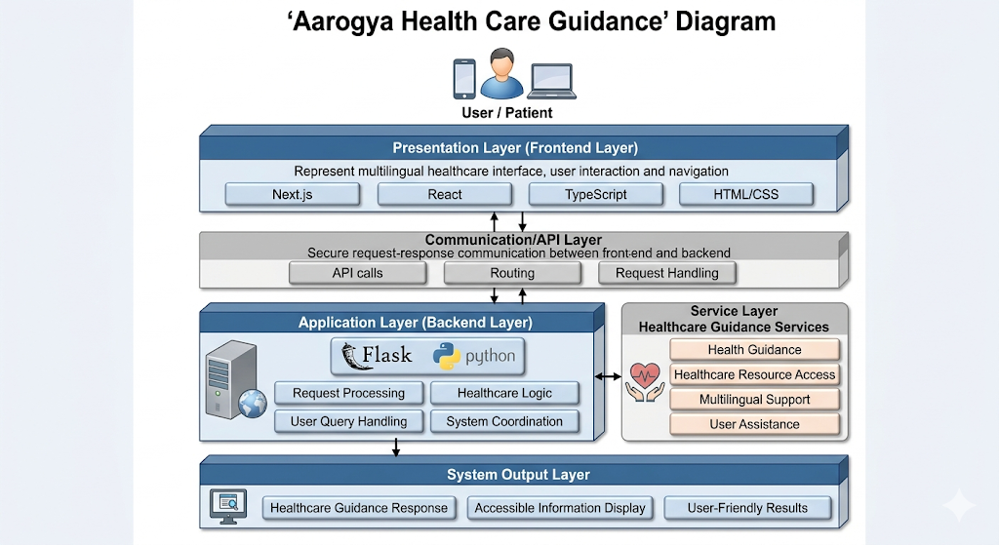
Data Flow
The data flow of Aarogya Health Care Guidance describes how user inputs are processed within the system to deliver appropriate healthcare-related outputs. The data flow begins when a user interacts with the frontend interface by accessing healthcare guidance features, searching for healthcare resources, or interacting with system functionalities. User requests are captured through the frontend and transmitted to the backend server for processing.
Once the request reaches the backend, Flask and Python-based processing modules analyze the request and determine the required functionality. Depending on the user’s action, the backend may process healthcare guidance requests, system navigation tasks, or healthcare-related data handling. After processing, the backend generates the appropriate response and sends it back to the frontend interface.
The frontend then displays the processed information to the user in an organized and understandable format. This continuous flow of information between frontend and backend ensures real-time system interaction and efficient functionality. The structured data flow improves user experience by ensuring timely responses and smooth communication throughout the platform.

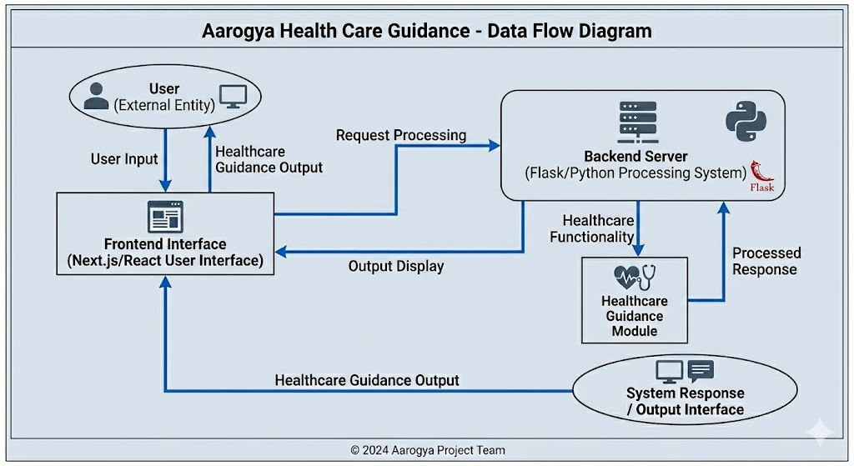
Performance Analysis with Metrics
Metric | Observation
User Accessibility | High due to user-friendly interface and structured healthcare guidance modules
Response Efficiency | Fast for frontend navigation and system interaction under standard conditions
Healthcare Guidance Functionality | Effective in providing organized healthcare-related assistance and accessibility support
Interface Responsiveness | High due to Next.js and React-based responsive frontend design
Multilingual Accessibility | Moderate to High depending on implemented language support modules

6. References
[1] Next.js, “Next.js Documentation.” [Online]. Available: https://nextjs.org/docs
[2] React, “React Documentation.” [Online]. Available: https://react.dev
[3] TypeScript, “TypeScript Documentation.” [Online]. Available: https://www.typescriptlang.org/docs/
[4] Python Software Foundation, “Python Documentation.” [Online]. Available: https://docs.python.org/3/
[5] Flask, “Flask Documentation.” [Online]. Available: https://flask.palletsprojects.com/
[6] JavaScript, “MDN Web Docs – JavaScript.” [Online]. Available: https://developer.mozilla.org/en-US/docs/Web/JavaScript
[7] HTML, “MDN Web Docs – HTML.” [Online]. Available: https://developer.mozilla.org/en-US/docs/Web/HTML
[8] CSS, “MDN Web Docs – CSS.” [Online]. Available: https://developer.mozilla.org/en-US/docs/Web/CSS
[9] GitHub, “GitHub Repository Hosting Platform.” [Online]. Available: https://github.com/
[12] npm, “Node Package Manager Documentation.” [Online]. Available: https://docs.npmjs.com/

7. Conclusion

The Aarogya Health Care Guidance project successfully demonstrates the design and development of an intelligent digital healthcare platform aimed at improving healthcare accessibility, awareness, and user support through modern web technologies. By integrating healthcare guidance functionalities with a responsive frontend and efficient backend framework, the system provides users with a structured and accessible platform for interacting with healthcare-related resources. The project highlights how technology can be utilized to address practical healthcare challenges by simplifying access to healthcare support and improving user engagement.
Through the implementation of technologies such as Next.js, React, TypeScript, Python, and Flask, the project effectively combines frontend responsiveness with backend functionality to create a scalable healthcare guidance solution.
The platform emphasizes user accessibility, healthcare awareness, and organized system integration, demonstrating the practical application of full-stack development in solving real-world healthcare problems. Its structured architecture and integrated modules reflect a balanced approach toward digital healthcare innovation.
Overall, the project contributed significantly to enhancing technical knowledge, practical development skills, and understanding of healthcare-focused system design. It demonstrates the potential of combining Artificial Intelligence concepts, web technologies, and healthcare service accessibility into a unified platform.

